My Target: ____ / 46 or ______ % Complete on the day of the test
(Circle when your test is handed back)

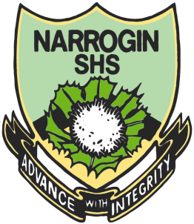
Name: __ Teacher:

Yr 8 Aboriginal Language & Culture Studies

Total marks  /46 | % | Weight  20%

Task One

Traditional Aboriginal Music & Musical Instruments

Due____________

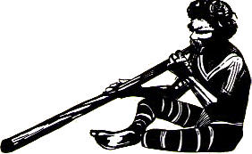

- Use your own knowledge and the Internet to do a draft Brainstorm about Traditional Aboriginal music and musical Instruments.
(10 marks)

- Draw examples of 3 or more instruments around the edges of your brainstorm. (6 marks)

- Once you have completed your Brainstorm bring it to your teacher and get it checked. You will then be given a piece of butcher paper to do your good copy on.

This good copy should be neat, colourful and informative. It should be suitable for display purposes.
(20 marks)

- Construct an Wordle using words you have researched about Traditional Aboriginal Music.
This Wordle must contain at least 20 words.
(10 marks)

What is a Wordle

A wordle is a visual depiction of the words contained in a piece of text or from a particular topic. Generated by a web-based tool of the same name, a wordle is created by manipulating the words and arranging them into a kind of graphic.

Below are 2 examples.

